Creative Electronics reflection

Creative Electronics has been one of the most challenging courses I have done since the start of the year. Electronics were never something that fascinated me, especially since I never connected it with design. Before this course, I always believed that anything that had to do with circuits and electricity was boring. However this course proved me wrong. I have learned so much more than I expected, and I feel like it also helped me develop more as a designer.
During the weeks, I had been learning a lot of new things. The first week was more comfortable since I was familiar with the board, some components, and the multimeter. The teensy kit was something that I was also familiar with since I followed the course Creative Programming. Thus, what was new for me was how to measure the different elements, how to measure the AC signal, which I found very interesting, and how the Oscilloscope worked. The Oscilloscope is something that I still find it a bit confusing, but by using it more while working in a lab will help me get the hang of it. After the first week, things got more complicated, and it was harder for me to follow. My partner also had the same issue since we had similar knowledge with this course. In response to this, we both tried to get help from fellow students, and with a lot of patience, we managed to catch up and understand all of the theory. Reporting on the labs was also something that I found confusing at first since I had never done that before. With the help of the feedback our teacher gave us, we learned a lot more on that, and we managed to develop our skills as a team and as individuals. The course, in general, went a lot deeper than I expected it, and it taught me so much.
Diodes and transistors was something that I also learned, with the result of also knowing how to connect a lamp in a circuit and also, how to create a circuit without using a lot of wires, since week by week, we had to add a lot more components in a circuit. Having a clean board with the least wires you could use is the best you can do to help yourself measure it easier and not get confused. That's also something that CE taught me, to be more tidy and careful. I also learned a lot about resistive circuits and operational amplifiers. I was also informed on how and when to add different opponents in a circuit, how to combine resistors, and how to measure different parts of it. Besides, I learned how to make everything into schematics with a lot of practice on different websites. Labs also trained me on how to behave, how to act while using specific elements, and that I had to work faster while having a time limit. The time I spend in there made me work more carefully but quicker at the same time. I gained a lot of knowledge through these weeks, and I value them a lot.
The heating system was the first assignment that we had to build ourselves without guidance, and it was also my first time making the whole circuit by myself since it was my responsibility at that time. At first, it was hard, but after going back on everything I had been learning since week 1, I managed to make the circuit work, and I was proud since I realized that my skills were developing. The mini-project, though, changed me, and it helped me a lot with becoming an independent engineer since we barely had any guidance, and we had to create it from scratch. While it sounded scary at first, It changed the way I see creative electronics. It also helped me develop my skills as a whole designer because I had to use my skills from other courses since we started with research, trying to get some ideas and inspiration. We wanted to connect our love for photography, our interest in LEDs, and our desire to keep the environment healthy so, we found a design that was eco-friendly and also not that complicated since the whole virus pandemic situation happened. My partner worked on the circuit, and I worked on the aesthetics and graphic designing part. We both worked on the design development. Not working on the circuit did not stop me from learning everything about every component that we had to use. I also helped my partner understand the use of the Arduino since it was something that I was taught during CP. It was nice to use something that we were already familiar with. Our result was terrific, it was a combination of technology and artistic photography, and I loved it. It made me realize that including technology in my life is not bad after all, and it will also provide me with better designing results.
After this course, I am more enveloped in the design and engineer world. The knowledge that I have gained will help me in the future since technology is an essential part of our society these days. I will also be able to go more deeply into electronics and learn more about connecting them with sounds since this is something that I wanted to combine my designs with. My goal is to participate in more projects that include electronics, so I can become even more experienced since practical work is what matters the most. I believe that knowing the theory of electronics is not what makes you a better engineer; it's the way you decide what you will use, how you use them and how you connect everything based on what you are creating and, of course, making it work. Then you know that you succeeded.
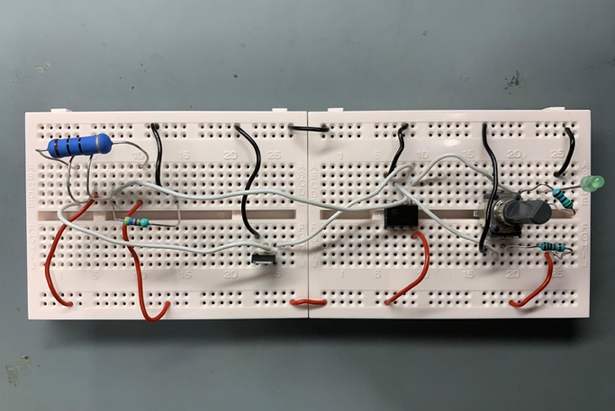
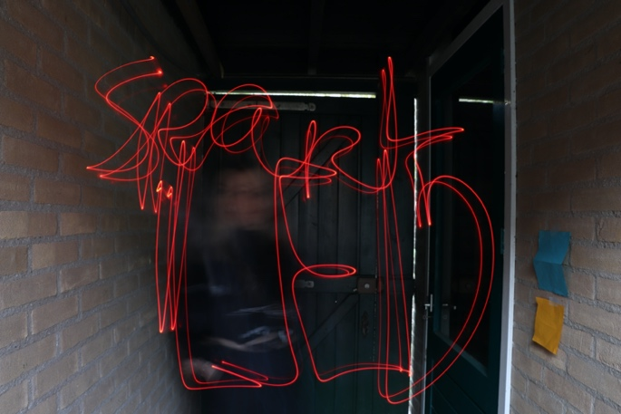
Mini project: the prototype
Heating system: the circuit
Mini project: the results
Mini project: the results
